# How to Deploy the SpringBoot Project:

You’ll need a PostgreSQL database and JDK 1.8 installed and running for deploying this project.

Once you have those requirements installed, you can continue to unzip the .zip file on any desired location, then open the unzipped folder, and open the testData.sql file.





This file contains DDL sentences for creating the database, as well as populating it with fake values. Execute this script on your Postgres PGAdmin.

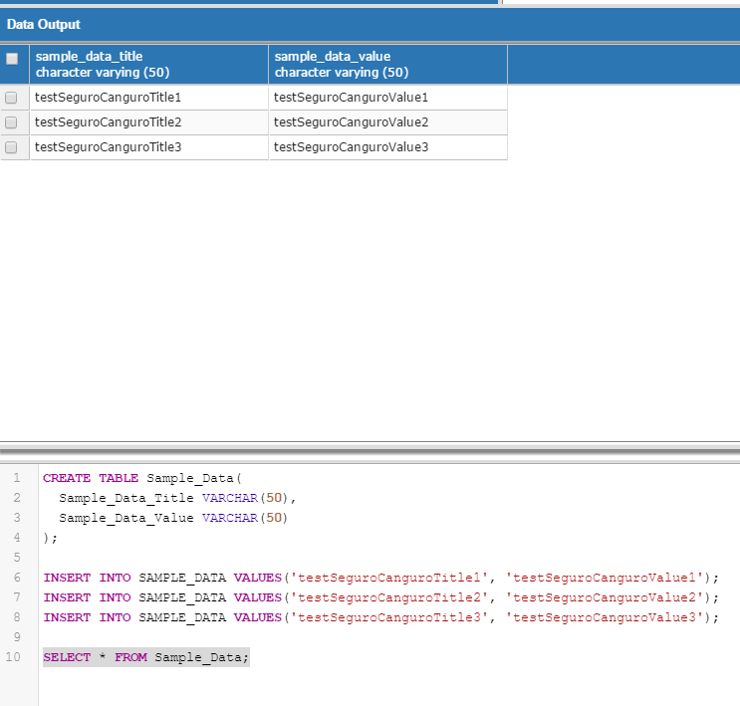

Now, go back to the root of the unzipped folder and open the target folder.

There, you must press CTRL + L, then CTRL + C to copy the folder’s address. Following this, open a command prompt and write the command <<*cd “previous path\surrounded_by_quotes\”>>*.

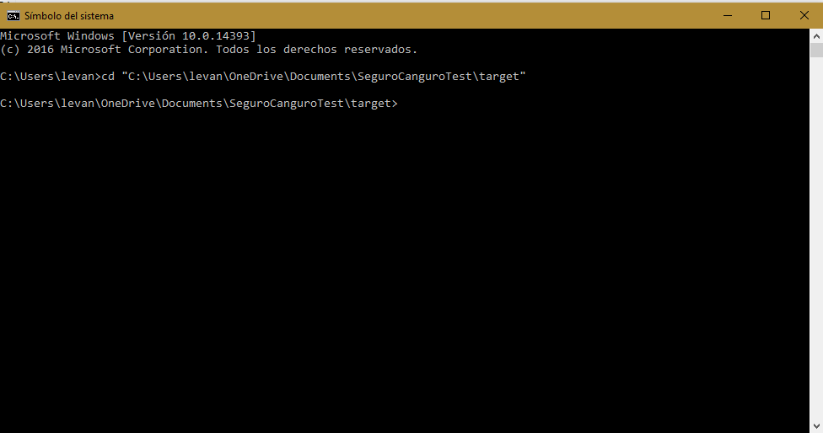

Next, you’ll need to execute the command “*java -jar SeguroCanguroTest-0.0.1-SNAPSHOT.jar*”

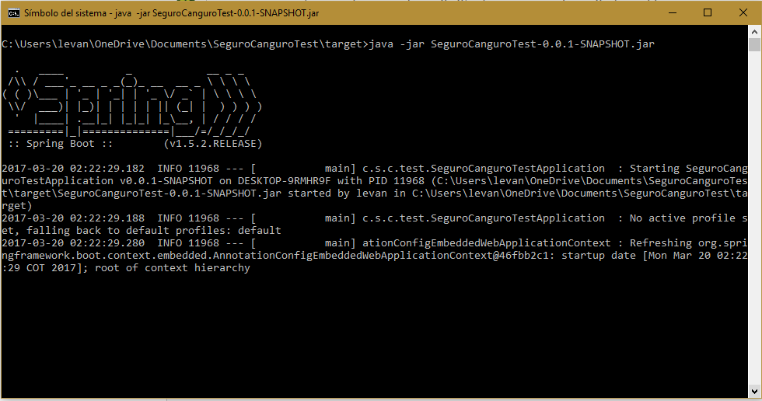

Finally, we’ll go back to the main directory once more. Here, we’ll head follow the breadcrumb web > views and open the file table.html.

You’ll see something like this:

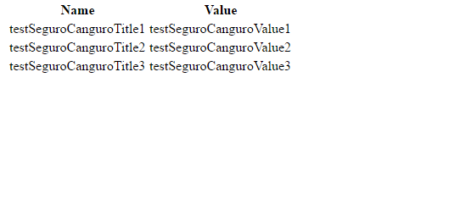

You can now play with the data as you wish to change the table.